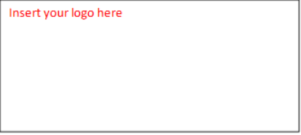

FOR IMMEDIATE RELEASE Month, Day, Year
MEDIA CONTACT:
[Name, cell phone, email]

[Your Organization’s Name] Joins National Lifesaving Coalition
Through its new partnership with Best Friends Animal Society, [organization name] gains national resources and support to help more dogs and cats find loving homes right here in our community.
[Your City, State] – [Your organization’s name] has joined the Best Friends Network, a national coalition of over 6,000 network partner shelters, rescues, and support organizations committed to saving the lives of dogs and cats.
The network is a program of Best Friends Animal Society, a leading national animal welfare organization working to save cats and dogs in America’s shelters.
Insert quote about why you joined the Best Friends Network and what this means for your lifesaving
Network partners receive support and resources designed to address their specific lifesaving needs. They also have access to specialized information, tools, data insights, and exclusive grant opportunities and events designed to save more lives.
“We are thrilled [organization name] is joining the Best Friends Network,” said Whitney Bollinger, Director of Strategy & Network Operations, Best Friends Animal Society. "Becoming a Best Friends Network Partner not only represents a strong commitment to lifesaving. It also puts the tools, support, and community in network partners’ hands, which directly leads to saving more cats and dogs.”
Learn more about [organization name] by visiting [insert link], and by following on Facebook [insert link] and Instagram [insert link]. Be part of the lifesaving by volunteering [insert link], adopting [insert link], or fostering [insert link].

Shelter boilerplate
About Best Friends Animal Society
Best Friends Animal Society is a leading animal welfare organization dedicated to saving the lives of dogs and cats in America's shelters and making the entire country no-kill. Founded in 1984, Best Friends runs lifesaving facilities and programs nationwide in partnership with more than 6,000 shelters and rescue organizations. From our headquarters in Kanab, Utah, we also operate the nation's largest no-kill animal sanctuary — a destination that brings our mission to life for thousands of visitors each year. We maintain the most comprehensive animal sheltering data in the country and make it accessible to the public — empowering communities with critical insights into the needs of their local shelters and how they can help. We believe every dog and cat deserves a home. And we believe that, by working together, we can Save Them All®. For more information, visit bestfriends.org.

